PT8612 Transmision lines

- jan 2006 Thomas Holm Hansen

PCB material parameters from: www.polycladlaminates.com

Transmission line from FPGA to Cable driver:
Ground plane: Mid Layer 2 (3rd layer)
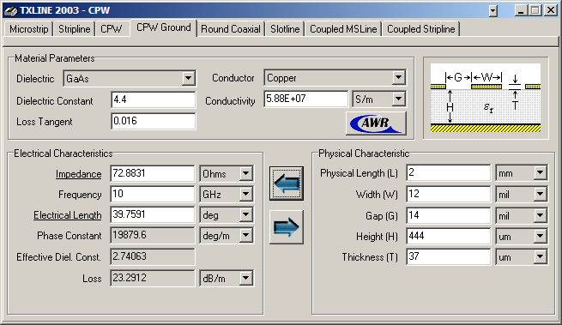

Transmision line after cable driver:
Ground plane: Bottom layer
